
This material and the accompanying software are proprietary and owned by Sage Accpac International, Inc. This material may not be duplicated, disclosed or reproduced in whole or in part for any purpose without the express written authorization of Sage Accpac International, Inc. All authorized reproductions must be marked with this legend.

Disclaimer:
This information and the software is provided “as is” and without any warranties of any kind, whether express, implied or statutory, including, without limitation, any implied warranty of merchantability or fitness for a particular purpose. Sage Accpac International, Inc shall not be liable for any direct, indirect, special, incidental or consequential damages which arise in connection with this information, and this limitation of liability will apply regardless of the form of action. The entire risk with respect to this information rests with you, and we suggest that you thoroughly evaluate the information before it is relied upon or used in any way.

Table of Contents
Table of Contents 2
Introductory Notes 3
Extracting the Tools 3
Sage Pro ERP Toolbox Setup 3
Block Test Tools 4
Class Compare Tool 4
Program Compare Tool 5
Table Compare Tool 6
Data Dictionary Compare Tool 6
Convert Code to SQL Tool 6
File Search Tool 6
Open Template Class Lib 6
Move Pro Tool 6
Paste Change Line Tool 7
Coverage/Performance Analyzer Tool 7
Upload Table to SQL Tool 7
Download Table from SQL Tool 8
Search SQL Server Reserved Words Tool 8
Check and Fix GL balances Tool 8

Introductory Notes
- Use these tools only in a development environment. We do not recommend using these tools with real data.
- Before using the tools, backup the programs/files/tables that will be affected by the tools.

Extracting the Tools
- Create a folder named “Tools” in your Sage Pro ERP root folder.
- Extract the files in Tools.zip to the Tools folder created.
- Create a Microsoft Visual FoxPro shortcut that points to the Sage Pro ERP root folder and uses the config.fpw file (located in the root folder).
- Modify the config.fpw and add the following line at the end:
COMMAND = DO sbtclean WITH .t.
- Quit out of Visual FoxPro and then load the short cut again.
- You should see a new menu bar named “Pro Tools”.

Sage Pro ERP Toolbox Setup
To make use of the Sage Pro ERP toolbox, select the Tools Menu and click Toolbox. When the toolbox opens, move the mouse over to the toolbox (anywhere within it) and right-click to display a context-sensitive menu. In the menu, choose “Customize Toolbox”.

You see the Customize Toolbox dialog box. Click “Options under the General folder and click on the […] button next to the toolbox table. Choose the Tools folder, select toolbox.dbf from the list, and click OK.

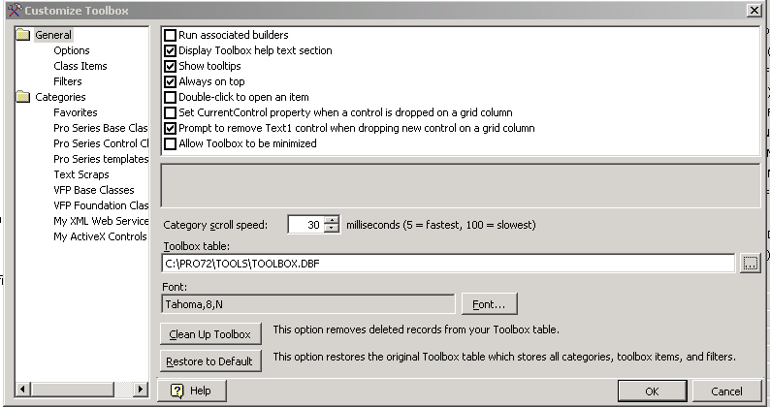

Usage
You have now set up the Sage Pro ERP toolbox. Anytime you are working with a Sage Pro ERP MDI window, you can use the toolbox to drop various controls easily.

Block Test Tools
This is a collection of two tools you can use to see if you hit all lines of code in a program or a class library. To use this tool, run the first tool to create block tests, and then use the second tool to analyze the results.

To create block tests, from the “Pro Tools” menu choose Block Test and Create Block Test. In the dialog that appears, choose the file you want to do the block test for and click Create Test.

☞ It is important that you have a backup of the files that you are going to use to create the block test (for class libraries it will be both the .VCX & .VCT).

Once you have created the blocks, run Sage Pro ERP and see that you get to hit the program/class library. Then exit Sage ProERP, and from the “Pro Tools” menu choose Block Test and Get Block Test Results. In the dialog that appears, hit Show Results to see which blocks are hit vs. which are not. You can click Open Source (or double-click on the line number in the grid) to take you to the line in the program/class library that has the block.

Class Compare Tool
This tool can be used to compare two versions of the same class library to determine what has changed.

To run this tool, click “Pro Tools” in the menu and then select Class Compare. You see a dialog that you can use to compare the class libraries.
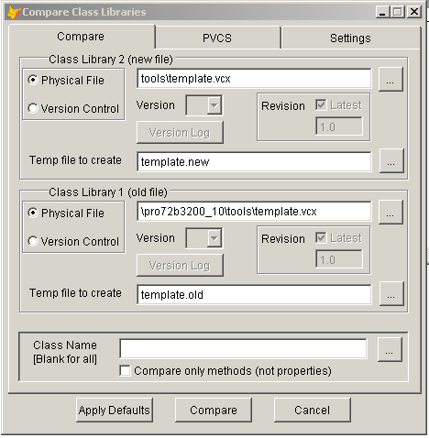

Notes:
- This tool is used by Sage to also compare the physical class library and version control. The batch file to exclude variables is used when a class library from the version control is needed, so you may not need to change this.
- The tool works by opening the class library as a table and then reading the memo fields and creating two text files from them. The tool will sort methods alphabetically (this is the nice part). Then a compare tool (we use examdiff which is can be downloaded at http://www.prestosoft.com/ps.asp?page=edp_examdiff for free). You can use any compare tool that can take two files as parameters and compare them.
- The tool will not report properties/methods added to the class (using add property, add method) that do not have any value set.
- Have a backup of the class libraries before running this tool.

Program Compare Tool
This tools works in a similar fashion as the class compare.

Table Compare Tool
You can use this tool, to compare two Visual FoxPro tables or a Visual FoxPro and a SQL table (if SQL is the backend). See the notes on the header of tools\dbfcompare for details on how to use the tool.

Data Dictionary Compare Tool
You can use this tool to generate data dictionary changes between two Sage Pro ERP builds. See the notes on the header of tools\DataDictCompare for details on how to use the tool.

Convert Code to SQL Tool
You can use this tool to convert code to use the new go_Sql approach introduced in Sage Pro ERP 7.0. You can run the tool from the “Pro Tools” menu.

This tool is the same as the one posted on our Web site in the Solution Provider section. The documentation for this tool is also provided on that site.

File Search Tool
This tool allows you to search prgs, vcxs and mprs for more than one string. Some of the benefits of the tool are:
- It allows you to search for more than one string in a program line. For example, you can search for all “m_ReplaceBulk” that replace “int1”.
- It combines command lines that have been broken over multiple lines using the semicolon continuation character into one line.
- Searches sub directories.
- Allows you to directly go to the line of code by clicking on “Open Source”.
- If you give a name to the search it will save it (the last 20 searches are saved).
- You can use regular expressions in the search.
- You can write a UDF that can be called during the search.

Open Template Class Lib
This gives you an idea of what template classes are available for use (see Error: Reference source not found). The template classes are ready to use classes for creating a standard Sage Pro ERP maintenance and a standard Sage Pro ERP transaction entry form.

Move Pro Tool
You can use this tool to move the Sage Pro ERP installation to a different folder. Copy the complete installation folder to a new folder and run this tool from that folder. This changes the path in system tables to point to the new destination folder. For SQL Server backend, it updates the system tables by reading the location from pro.ini.

☞ Before running the tool run “DO tools\sqltest” to load up go_Sql. This needs to be done both for Visual FoxPro or SQL server backend.

- If there are some customizations done and the customized are stored in the pro directory, performing this operation would assign the customization tables with the new folder to which pro was moved. Note that for paths outside pro directory, performing this operation will not change the path.

Paste Change Line Tool
This tool will keyboard change line comments (these are set to the Sage Pro ERP standard). You may need to modify the tool to use your own change line format.

Coverage/Performance Analyzer Tool
This tool can be used to find which program line(s) consumes the most time when doing a particular task. To use this tool, you have to create a coverage log file using the Visual FoxPro coverage tool. To do this, before the line that begins the task have a
SET COVERAGE TO <logfile name.log>. After the line that ends the task have a
SET COVERAGE TO.

- Create a backup of the program/class files before using the tool.
- The tool causes the code to execute slightly slower (to create the log file).
- Note that there are no wait states (like a Read, Wait Window, Form.Show()) in between those lines.

Run Sage Pro ERP and see those lines are hit and then exit Sage Pro ERP. Now run the tool from the Pro Tools menu and point to the log file created. It brings up a browse that has the line that is the slowest on the top. Note that the slowest line is slow because it calls some other function/procedure that is slow and that calls some other function/procedure. Scroll down to the line that is slow without it calling any other function/procedure. Now hit <Ctrl-O> to open the source of that line.

☞ In some cases, it might be a single line that is slow or a group of lines that are slow. In this case, you can reduce the coverage to those few lines.

Upload Table to SQL Tool
Use this tool to copy a Visual FoxPro table to a SQL server table. You can either create a new SQL server table or upload to an existing SQL table. If uploading to an existing SQL table:
- All the records in the SQL table will be deleted first.
- If the Visual FoxPro table has fields that are not there in the SQL table, an error will occur.

Before running the tool, run “DO tools\sqltest” to load up go_Sql to work with SQL server.

☞ It is strongly recommended that you use this only for sample data. Also, have a complete backup of the data before and after using the tool and verify that the tool updated data properly.

Download Table from SQL Tool
Use this tool to copy a SQL server table to a Visual FoxPro table. You can either create a new Visual FoxPro table or upload to an existing one. If downloading to an existing table:
- All the records in the Visual FoxPro table are deleted first.
- If the Visual FoxPro table has fields that are not there in the SQL table, an error will occur.
- Remember that Visual FoxPro tables have limitations (like 2GB for the table size).

Before running the tool you should run “DO tools\sqltest” to load up go_Sql to work with SQL server.

☞ It is strongly recommended that you use this only for sample data. Also, have a complete backup of the data before and after using the tool and verify that the tool updated data properly.

Search SQL Server Reserved Words Tool
You can use this tool to search your Sage Pro ERP Data Dictionary for custom fields that conflict with SQL Server reserved words. The reserved words that shipped with Sage Pro ERP (earlier to Sage Pro ERP 7.x) are removed during installation.

Check and Fix GL balances Tool
Starting with Sage Pro ERP version 7.4, you need to run this tool from the System Manager menu. Please read Doc On Disk for details.

Load Pro screens without having to load the menu
☞ This will work only from Sage Pro ERP 7.4.
☞ Use this tool only in a development environment.

This tool will enable you to login to Pro and select particular screen with just two commands. This will be useful for testing during development.
The tool "ProLoadApp" can be executed to login as ADMN and load a specific application/company's object. It has 3 parameters,
pc_Applid (Required), pc_compid (optional) and pl_Showmenu.
Eg.
DO tools\ProLoadApp WITH "AP", "99", .t.
Subsequently, the tool "ProRunMenu" can be executed to launch a particular form using its menu id. This has only one parameter, pc_menuid (Required). The menu ID can be taken from the table SYMMENU.DBF
Eg.
DO tools\ProRunMenu WITH "M00001 "

Builders
Sage Pro ERP tools has a nice set of builders. These can help you to quickly create new MDI screens and add objects to them. All builders can be run by selecting an appropriate object on the form and then right click and choose “Builders”. Some of the builders we have are
Name | Description
Add Objects | This can be used to add objects to MDI forms.  In the command window type “DO tools\sqltest” to load the Sql object.  Open any MDI formset class, choose a table component in the data manager and then right click and choose builder and then choose the “Add Object builder”. You will now get a screen that has all the fields for that table (from sydflds). Click on “General Settings” to change some options. For some objects, based on the class of the object, you will can set some properties by clicking on the “Class settings” tab. You can also change the class of an object. Select the fields you want and then drag the object that says “Drag me…” to an area of the form and release the object.
Change Class | You can change the class of any object on the form by using this builder.
View m_Doc | All foundation classes have ready reference help stored in a method called m_Doc. You can see all this by using this builder.
View parent class code | Use this builder to see the code for a method in all the parent classes of that object.
Resize Page frame container | Choose the page frame (note that when you click on the pageframe you are choosing the container that holds the page frame. Right click and choose edit and now you have selected the page frame). Then you can run this builder to resize the page frame containers to fit the new page size
Add Page | Choose the page frame (note that when you click on the pageframe you are choosing the container that holds the page frame. Right click and choose edit and now you have selected the page frame). Then you can run this builder to add a new page.
Resize Page container | Choose the page frame (note that when you click on the pageframe you are choosing the container that holds the page frame. Right click and choose edit and now you have selected the page frame). Then you can run this builder to resize the page containers in the page frame.

